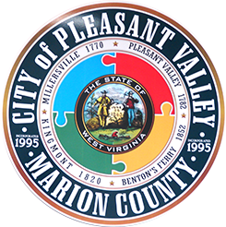
A G E N D A
City of Pleasant Valley

Tuesday, September 15, 2020
CITY COUNCIL MEETING 7:00 PM

Facebook: https://www.facebook.com/cityofpv
Email: cityofpvalley@aol.com
Phone: 304-363-2400
Web: www.cityofpleasantvalley.com

Council Meeting – 7:00 PM
- Pledge of Allegiance
- Call to Order
- Approval of Minutes
  - August 18, 2020 – Work Session
  - August 18, 2020 – Council Meeting
- Financial Report – August 2020
- VVFD Report

HOTEL/MOTEL/CONTRIBUTIONS –
- East Fairmont High School Senior Fund - $3,000 (approx.) …………… Emily Haddix
- Celebration of Lights Fund - $2,000 ……………………………………………… Emily Haddix

BUSINESS REVIEW
- Introduce City Clerk Sherry Roof
- Building Commission Emily Haddix
- Fall City Clean-Up / Smallwood Sanitation Bid Emily Haddix
- Recreational Complex - Update Chip Phillips
- City Athletic Fields - Enhancements and Maintenance Emily Haddix
- Road Improvements - Update Chip Phillips
- Annexation - Update John Funkhouser
- Drainage, Flooding, and Other Road Work Emily Haddix
- Code Enforcement Report John Miller
- Council Comments
- Citizen Concerns
- Adjournment (motion)

Please practice social distancing and wear a mask if attending in person.
Next Council Work Session - October20, 2020 @ 6:00 p.m.
Next Council Meeting - October 20, 2020 @ 7:00 p.m.

