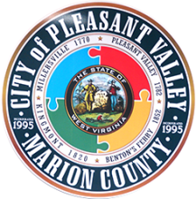
A G E N D A
(Updated 12/09/20)
City of Pleasant Valley
2340 Kingmont Road
Pleasant Valley, WV 26554

City Council Meeting/Tuesday, December 15, 2020 – 7:00 pm

Council Meeting – 7:00 PM, Tuesday, December 15, 2020
- Pledge of Allegiance
- Call to Order
- Approval of Previous Meeting Minutes
- Financial Report
- VVFD Report

Hotel/Motel Contributions - Requests
- Fairmont Woman’s Club ($2,000)
- Three Rivers Festival ($1,000)

Business Review
- Building Commission (updated item)
- Drainage, flooding, and other road work
- Grant management
- Ordinance review
- Snow Plowing Bids (updated item)
- Year in review wrap-up
- Code enforcement report
- Council comments
- Citizen concerns
- Adjournment (motion)

Note: Live a feed will available via Facebook at https://www.facebook.com/cityofpv

Please practice social distancing and wear a mask if attending in person.

Next Council Work Session – January 12, 2021 @ 6:00 p.m.
Next Council Meeting – January 19, 2021 @ 7:00 p.m.

