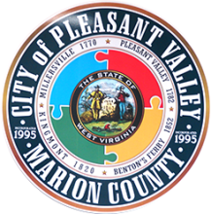
A G E N D A
City of Pleasant Valley
City Council Work Session/Tuesday, December 8, 2020 – 6:00 pm

Work Session – 6:00 PM, Tuesday, December 8
- Authority and responsibilities – a broad discussion
- Boards, commissions, committees
- City contract review; other city services/business partners
- City events
- City office procedures – processing and process updates; needs; equipment; new initiatives
- Community partnering
- Current and new initiatives
- Drainage, flooding, and other road work
- Financial overview
- Grant management
- Ordinance review – continuing (Ordinances 5 & 6)
- Sustainable growth discussion
- Visitor center ideas
- Year in review wrap-up

Please practice social distancing and wear a mask if attending in person.
Next Council Work Session – TBA
Next Council Meeting – December 15, 2020 @ 7:00 p.m.

