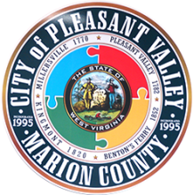
A G E N D A
City of Pleasant Valley
2340 Kingmont Road
Pleasant Valley, WV 26554

City Council Meeting/Tuesday, January 26, 2021 – 7:00 pm
Special Notice: Due to the pandemic, this meeting will be via Zoom; we will NOT be meeting in person at this time.

Council Meeting – “Rescheduled’ from January 19th to accommodate for online preparations.
- Pledge of Allegiance
- Call to Order
- Approval of Previous Meeting Minutes
- Financial Report
- VVFD Report

Hotel/Motel Contributions - Requests
- Fairmont Woman’s Club ($2,000 request)
- Three Rivers Festival ($1,000 request)
- Woodlawn Cemetery Company ($2,000 request) - New

Business Review
- Building Commission update
- Drainage flooding and road work update
- Ordinance review
- Dura Edge quote
- Filling office assistant position
- Office computers
- Council updates
- Citizen concerns
- Adjournment (motion)

As usual, a live a feed will available via Facebook at https://www.facebook.com/cityofpv

Note: All public meetings will be via Zoom until further notice.

Next Online Council Meeting – February 16, 2021 @ 7:00 p.m.

